PARAS Grammar School – First Term Exam
Course Title | Computer Science | Instructor/s | Mr. Aoun Haider
Class | 9th | Syllabus | Chapter 1
Time Allowed | 2 hour | Date | 19-05-2025 | Total Marks | 50
Student Name |  | Roll No
Important Instructions/Guidelines:
- Attempt all the questions
- Solve all the questions on question paper except q no. 2, 3
- Return the question paper along with your answer sheet
(Ali Raza bad near Ali Town Station Lahore)
Q#01: Marks the correct option. [1x5 = 5 Marks]
- Which bus among the following transports data?
- Address Bus | - Data Bus
- Control Bus | - Serial Bus
- Von-Neumann architectures was developed in
- 1942 | - 1941
- 1940 | - 1945
- Random Access Memory (RAM) is ________________ memory.
- Transient | - Permanent
- Both (a) and (b) | - None of these
- Sorting algorithms
- Disorganize data | - Removes data
- Reverse data | - Arrange data
- Input Device
- Keyboard | - Mouse
- Printer | - Both (a) and (b)

Q#02: Attempt any five short questions: [2x5 = 10 Marks]
1. Define Software Engineering Systems?
2. Differentiate between natural science and design science?
3. Define static systems.
4. What is computer science?
5. Explain Information Management Systems.
6. Write a brief note on Psychological Systems.
7. Differentiate between Natural Systems and Artificial Systems.
8. How a system interacts with its environment?
Q#03: Long Question [1x10 = 10 Marks]
1. Write a detail note Von-Neumann architecture with its 4 components.
1

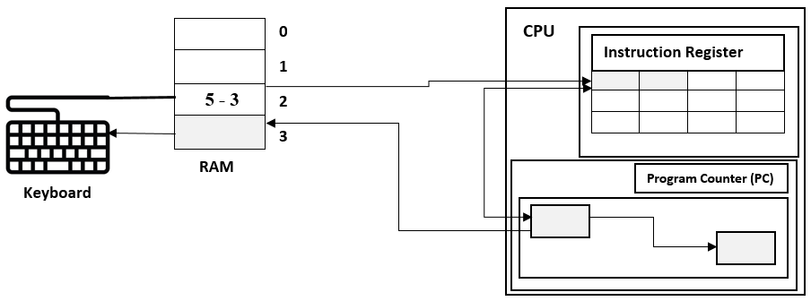
Q#04: Label the given diagram of CPU execution cycle (only gray shaded boxes). [5 Marks]
Q#05: Identify type of systems in the given scenario [1x10 = 10 Marks]
A plant grows towards sunlight, changes with seasons, and depends on water and nutrients.
A traffic light changes signals at regular intervals based on a set timer.
Ali makes his decisions based on emotions, thoughts, and past experiences.
A weather forecasting model uses historical data and algorithms to predict future conditions.
A computer solves math problems exactly as programmed, without deviation.
A classroom full of students interacts with each other, forming friendships and study groups.
The human digestive system breaks down food and absorbs nutrients.
A volcano erupts due to pressure buildup, affecting the surrounding ecosystem.
A factory uses machines and workers to assemble cars according to specific designs.
A chatbot uses previous queries to generate helpful responses in real time.
Q#06: Redraw the given regulative cycle of design science in correct order [5 Marks]
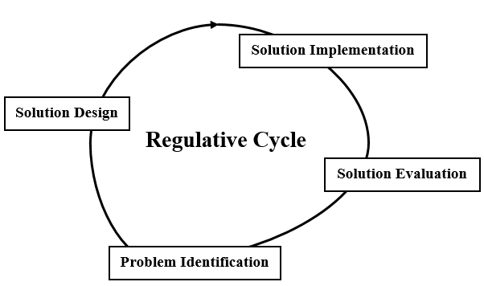

Q#07: Refer to Fig-1 and Identify CPU execution state in the given scenario [Fetch, Decode, Execute, Store] [5 Marks]
The control unit retrieves the next instruction from memory
The CPU processes the binary opcode to determine the instruction's meaning.
The arithmetic logic unit (ALU) adds two numbers.
The result of a calculation is written to a register.
The CPU accesses RAM to get the data needed for an instruction.

